**SQL Assignment-2**

**Retrieve data using join with where clause**

CREATE TABLE Salesman

(

salesman_id INT IDENTITY (5001,1) PRIMARY KEY,

name VARCHAR(20),

city VARCHAR(20),

commission decimal(2,2)

);

CREATE TABLE Customer

(

customer_id INT IDENTITY (3001,1) PRIMARY KEY,

cust_name VARCHAR(20),

city VARCHAR(20),

grade INT,

salesman_id INT

);

CREATE TABLE Orders

(

ord_no INT IDENTITY (70001,1) PRIMARY KEY,

purch_amt DECIMAL(5,2),

ord_date DATE,

customer_id INT,

salesman_id INT

);

INSERT INTO Salesman VALUES('John' , 'Baroda','0.15');

INSERT INTO Salesman VALUES('Ben Stocks' , 'Surat','0.13');

INSERT INTO Salesman VALUES('Kohli' , 'Mumbai','0.12');

INSERT INTO Salesman VALUES('Pit Alex' , 'London','0.11');

INSERT INTO Salesman VALUES('Malan' , 'Bhavnagar','0.14');

INSERT INTO Salesman VALUES('Paul Adom' ,'Rome','0.13');

INSERT INTO Customer VALUES('Yash','Damnagar','100','5001');

INSERT INTO Customer VALUES('Harshil','Surat','200','5001');

INSERT INTO Customer VALUES('Shrey','Bhavnagar','300','5002');

INSERT INTO Customer VALUES('Sagar','Baroda','100','5003');

INSERT INTO Customer VALUES('Bhavesh','Mumbai','300','5004');

INSERT INTO Customer VALUES('Gaurav','Patan','200','5003');

INSERT INTO Customer VALUES('Vivek','Gandhinagar','100','5005');

INSERT INTO Customer VALUES('Chirag','Rajkot','200','5006');

INSERT INTO Orders VALUES('150.5','2022-02-06','3005','5002');

INSERT INTO Orders VALUES('270.65','2022-02-07','3001','5001');

INSERT INTO Orders VALUES('450.75','2022-08-06','3002','5005');

INSERT INTO Orders VALUES('134.15','2022-09-09','3001','5004');

INSERT INTO Orders VALUES('167.25','2022-09-06','3002','5003');

INSERT INTO Orders VALUES('356.35','2022-08-06','3005','5006');

INSERT INTO Orders VALUES('178.95','2022-10-06','3004','5002');

INSERT INTO Orders VALUES('350.55','2022-02-06','3006','5001');

INSERT INTO Orders VALUES('190.65','2022-07-07','3008','5004');

INSERT INTO Orders VALUES('107.75','2022-02-10','3005','5003');

1) write a SQL query to find the salesperson and customer who reside in the same city. Return Salesman, cust_name and city

SELECT name AS Salesman,

Customer.cust_name,

Customer.city

FROM Customer,Salesman

WHERE Salesman.city = Customer.city;

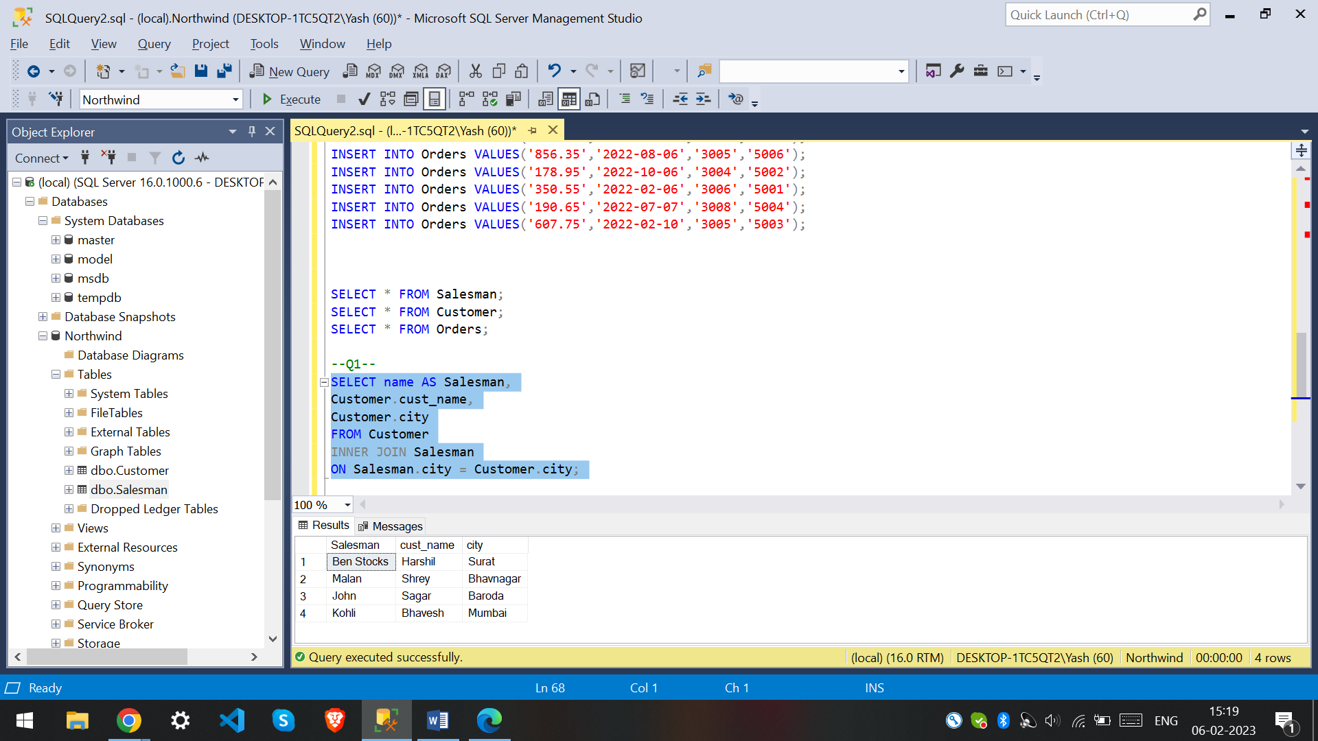

2) write a SQL query to find those orders where the order amount exists between 500 and 2000. Return ord_no, purch_amt, cust_name, city.

SELECT Orders.ord_no, Orders.purch_amt,Customer.cust_name,Customer.city

FROM Orders INNER JOIN Customer

ON Orders.customer_id=Customer.customer_id

WHERE Orders.purch_amt BETWEEN 500 AND 2000;

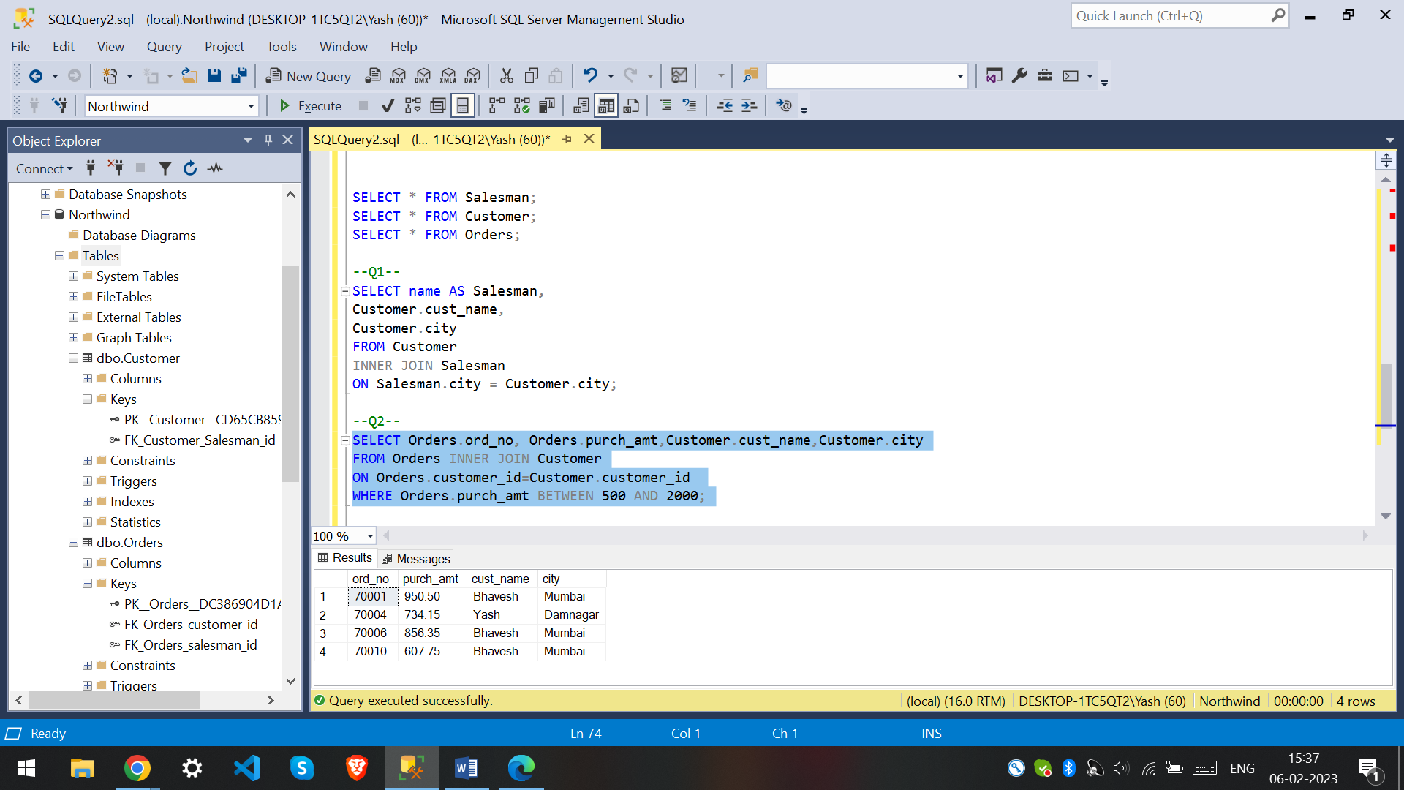

3. write a SQL query to find the salesperson(s) and the customer(s) he represents. Return Customer Name, city, Salesman, commission

SELECT Customer.cust_name,Customer.city,Salesman.name,Salesman.commission

FROM Customer INNER JOIN Salesman

ON Customer.salesman_id = Salesman.salesman_id;

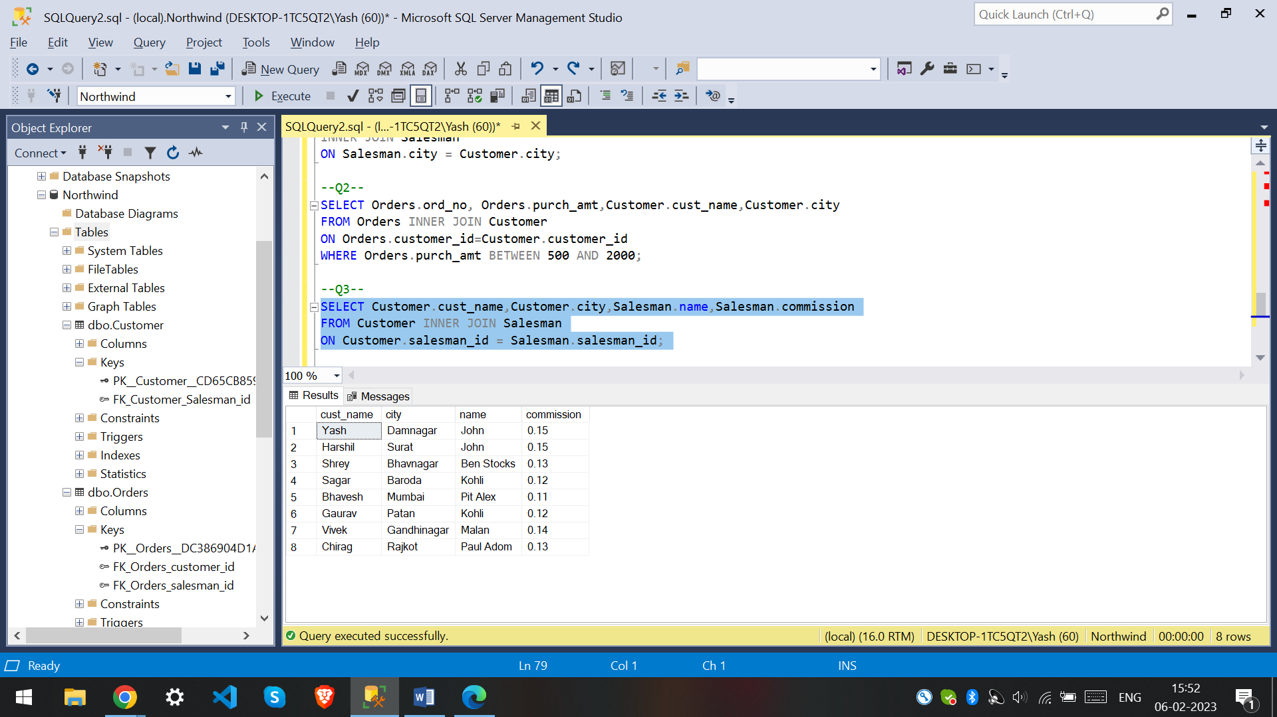

4. write a SQL query to find salespeople who received commissions of more than 12 percent from the company. Return Customer Name, customer city, Salesman, commission.

SELECT Customer.cust_name,Customer.city,Salesman.name,Salesman.commission

FROM Customer INNER JOIN Salesman

ON Customer.salesman_id = Salesman.salesman_id

WHERE Salesman.commission > 0.12;

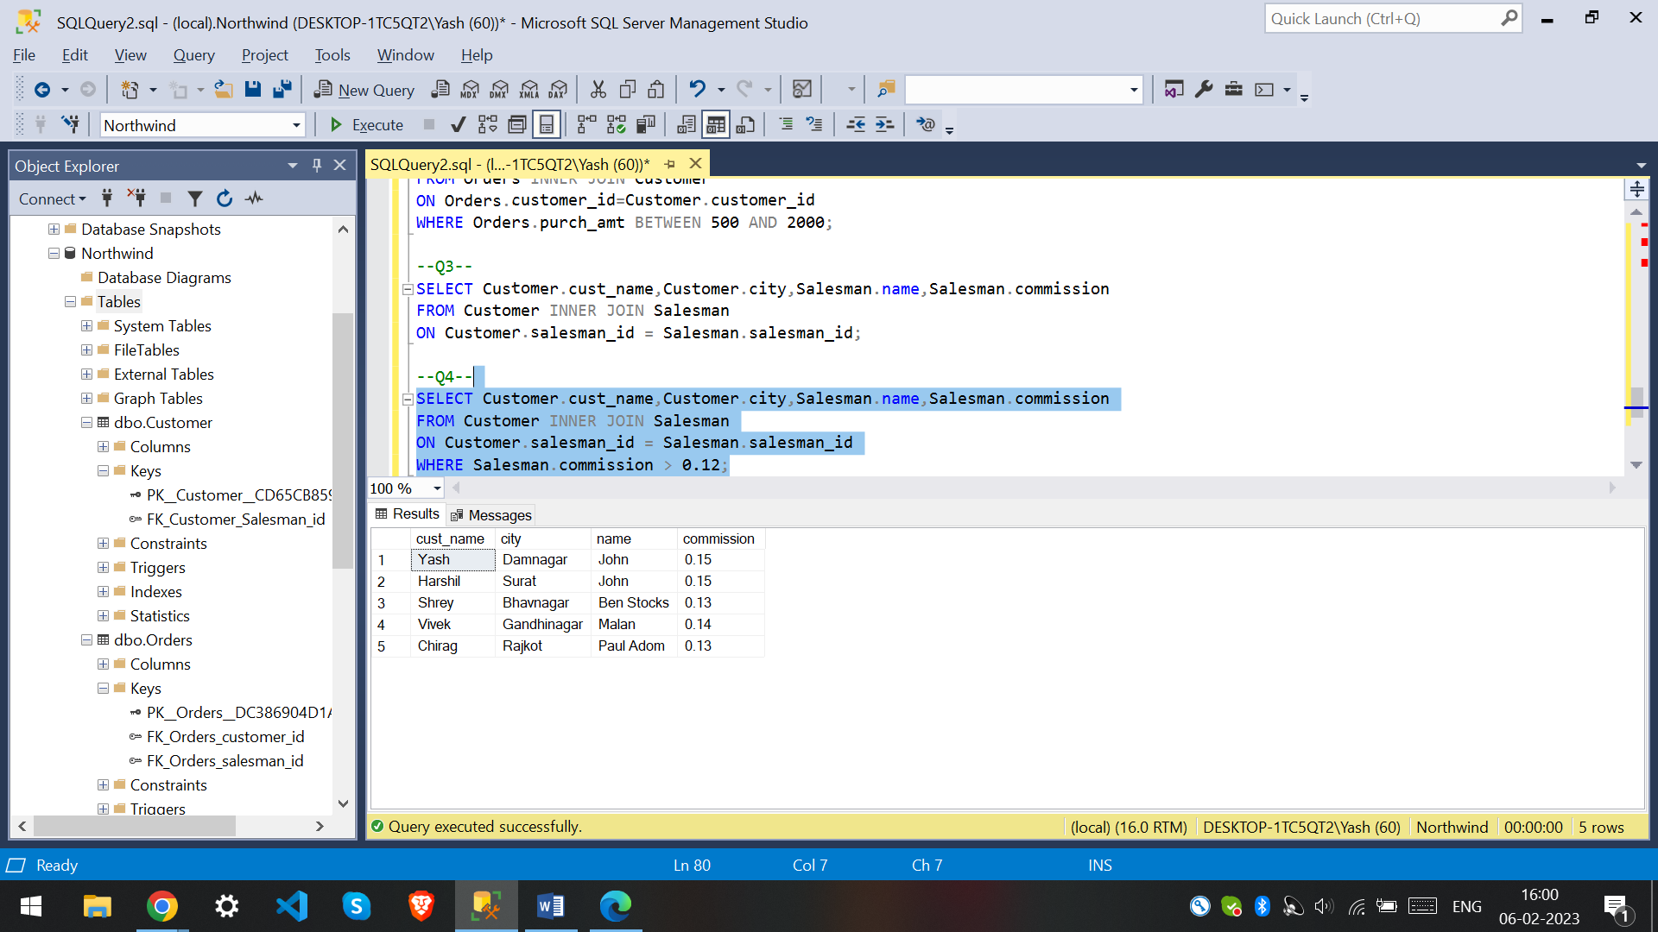

5. write a SQL query to locate those salespeople who do not live in the same city where their customers live and have received a commission of more than 12% from the company. Return Customer Name, customer city, Salesman, salesman city, commission

SELECT Customer.cust_name,Customer.city,Salesman.name,Salesman.city,Salesman.commission

FROM Customer INNER JOIN Salesman

ON Customer.salesman_id = Salesman.salesman_id

WHERE Salesman.commission > 0.12 AND Customer.city <> Salesman.city;

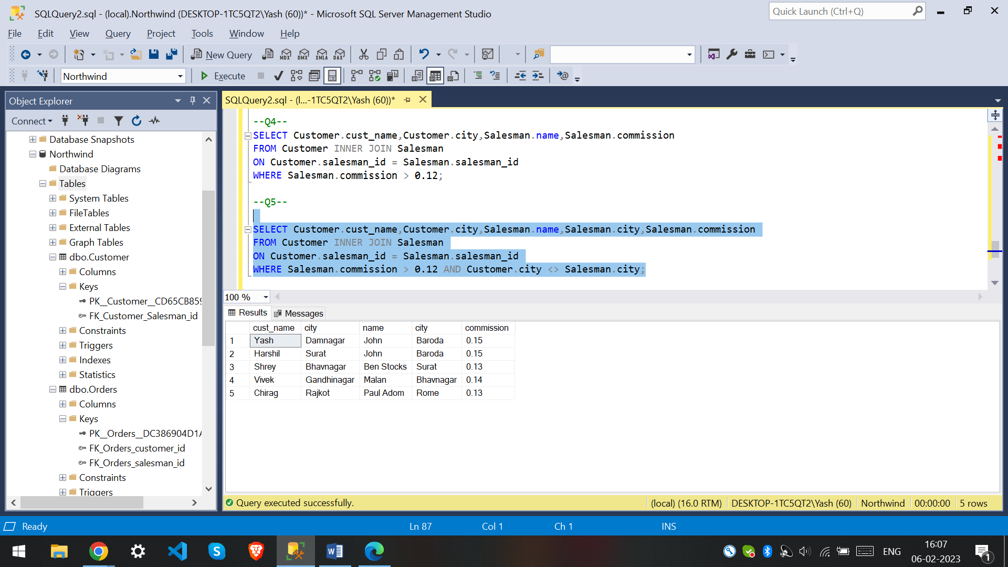

6. write a SQL query to find the details of an order. Return ord_no, ord_date, purch_amt, Customer Name, grade, Salesman, commission

SELECTOrders.ord_no,Orders.ord_date,Orders.purch_amt,Customer.cust_name,Customer.grade,Salesman.name,Salesman.commission

FROM Orders

JOIN Customer

ON Orders.customer_id = Customer.customer_id

JOIN Salesman

ON Orders.salesman_id = Salesman.salesman_id;

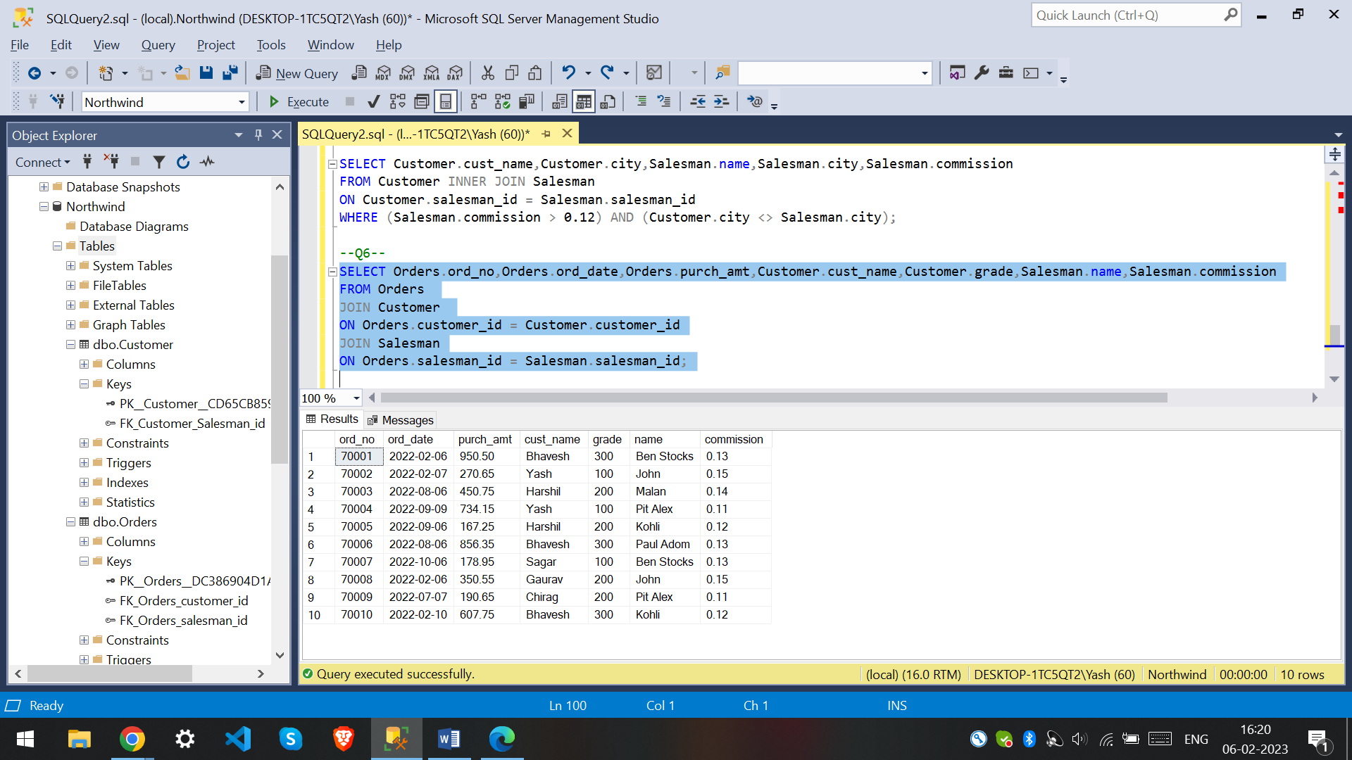

7. Write a SQL statement to join the tables salesman, customer and orders so that the same column of each table appears once and only the relational rows are returned.

--Q7--

SELECT S.salesman_id , S.name AS salesman_name,

C.customer_id, C.cust_name AS customer_name, C.grade,

O.ord_no, O.purch_amt

FROM Salesman S

JOIN Customer C

ON S.salesman_id = C.salesman_id

JOIN Orders O

ON C.customer_id = O.customer_id;

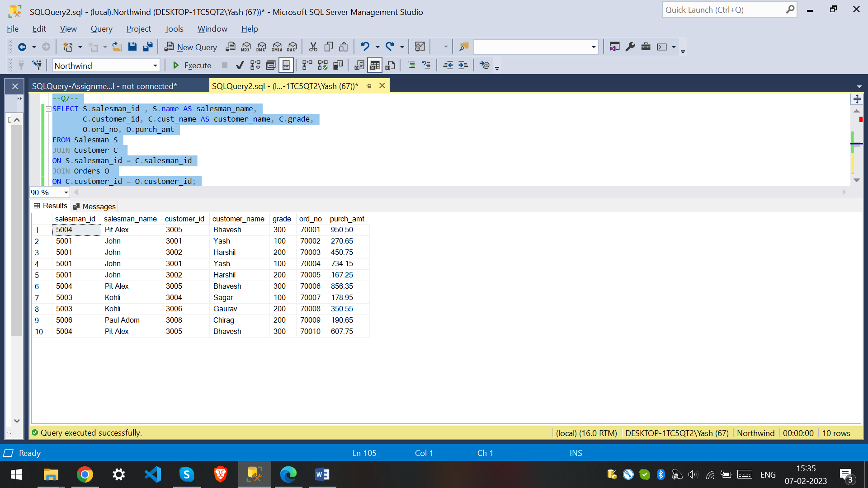

8. write a SQL query to display the customer name, customer city, grade, salesman, salesman city. The results should be sorted by ascending customer_id.

SELECT C.cust_name, C.city , C.grade , S.name, S.city

FROM Customer C

LEFT JOIN Salesman S

ON C.salesman_id = S.salesman_id

ORDER BY customer_id ASC;

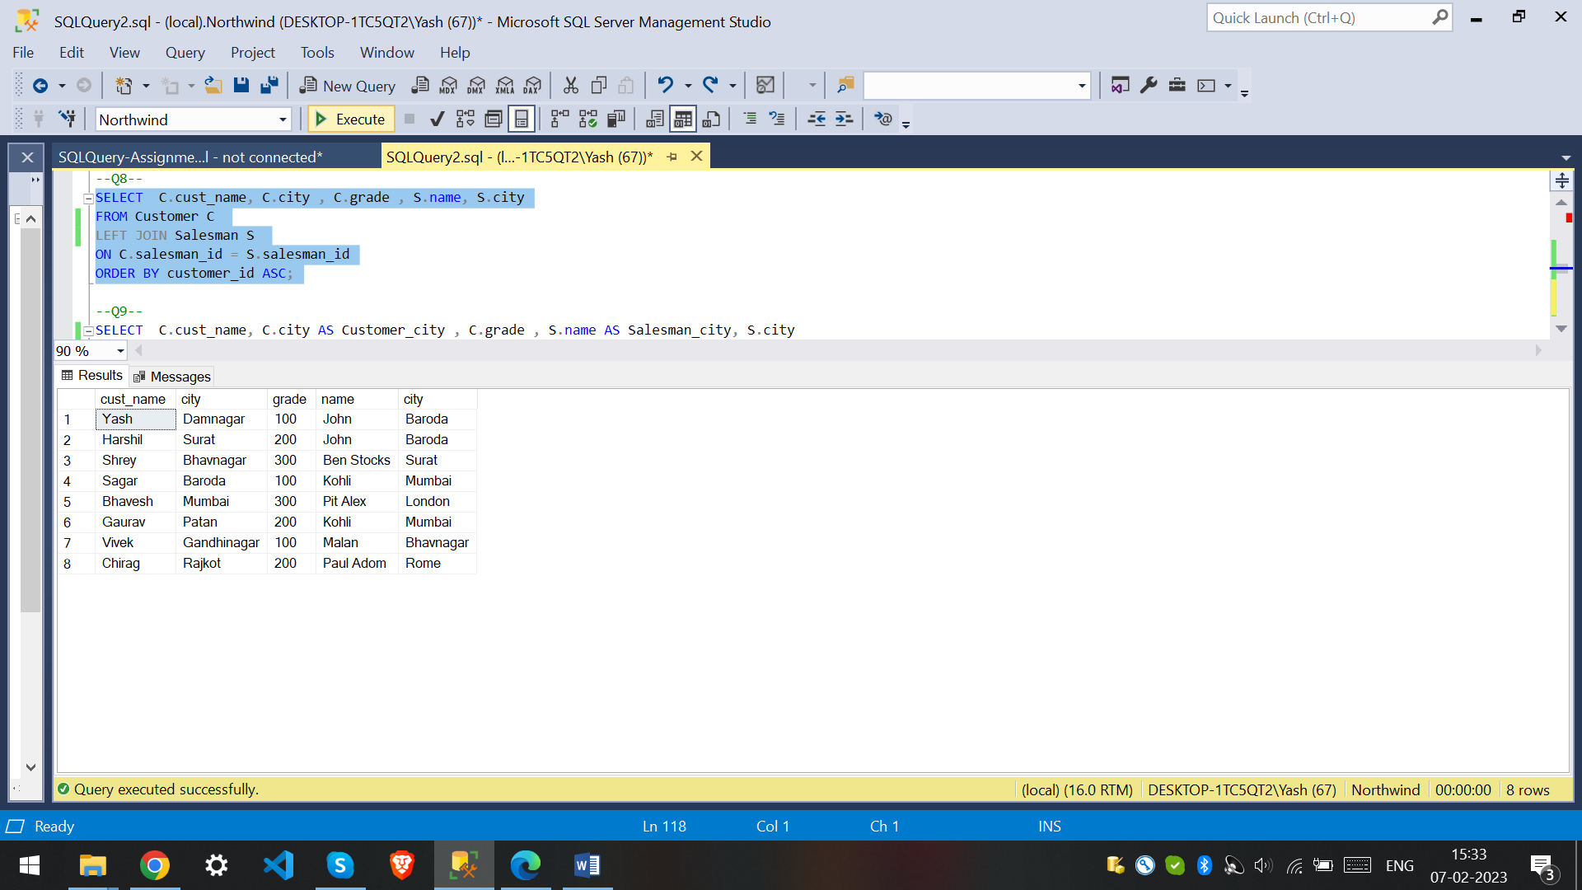

9. write a SQL query to find those customers with a grade less than 300. Return cust_name, customer city, grade, Salesman, salesmancity. The result should be ordered by ascending customer_id.

SELECT C.cust_name, C.city AS Customer_city , C.grade , S.name AS Salesman_city, S.city

FROM Customer C

LEFT JOIN Salesman S

ON C.salesman_id = S.salesman_id

WHERE C.grade < 300

ORDER BY customer_id ASC;

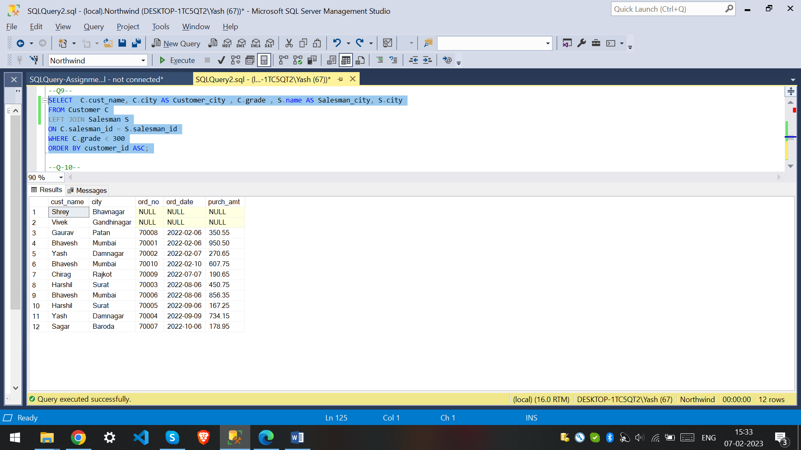

10. Write a SQL statement to make a report with customer name, city, order number, order date, and order amount in ascending order according to the order date to determine whether any of the existing customers have placed an order or not

SELECT C.cust_name, C.city , O.ord_no , O.ord_date , O.purch_amt

FROM Customer C

LEFT JOIN Orders O

ON C.customer_id = O.customer_id

ORDER BY ord_date ASC;

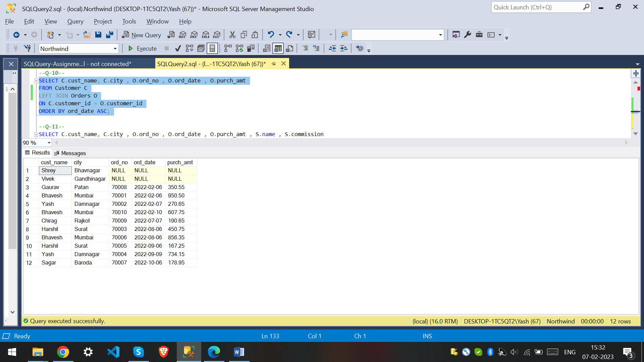

11. Write a SQL statement to generate a report with customer name, city, order number, order date, order amount, salesperson name, and commission to determine if any of the existing customers have not placed orders or if they have placed orders through their salesman or by themselves

SELECT C.cust_name, C.city , O.ord_no , O.ord_date , O.purch_amt , S.name , S.commission

FROM Customer C

LEFT JOIN Orders O

ON C.customer_id = O.customer_id

LEFT JOIN Salesman AS S

ON C.salesman_id = S.salesman_id;

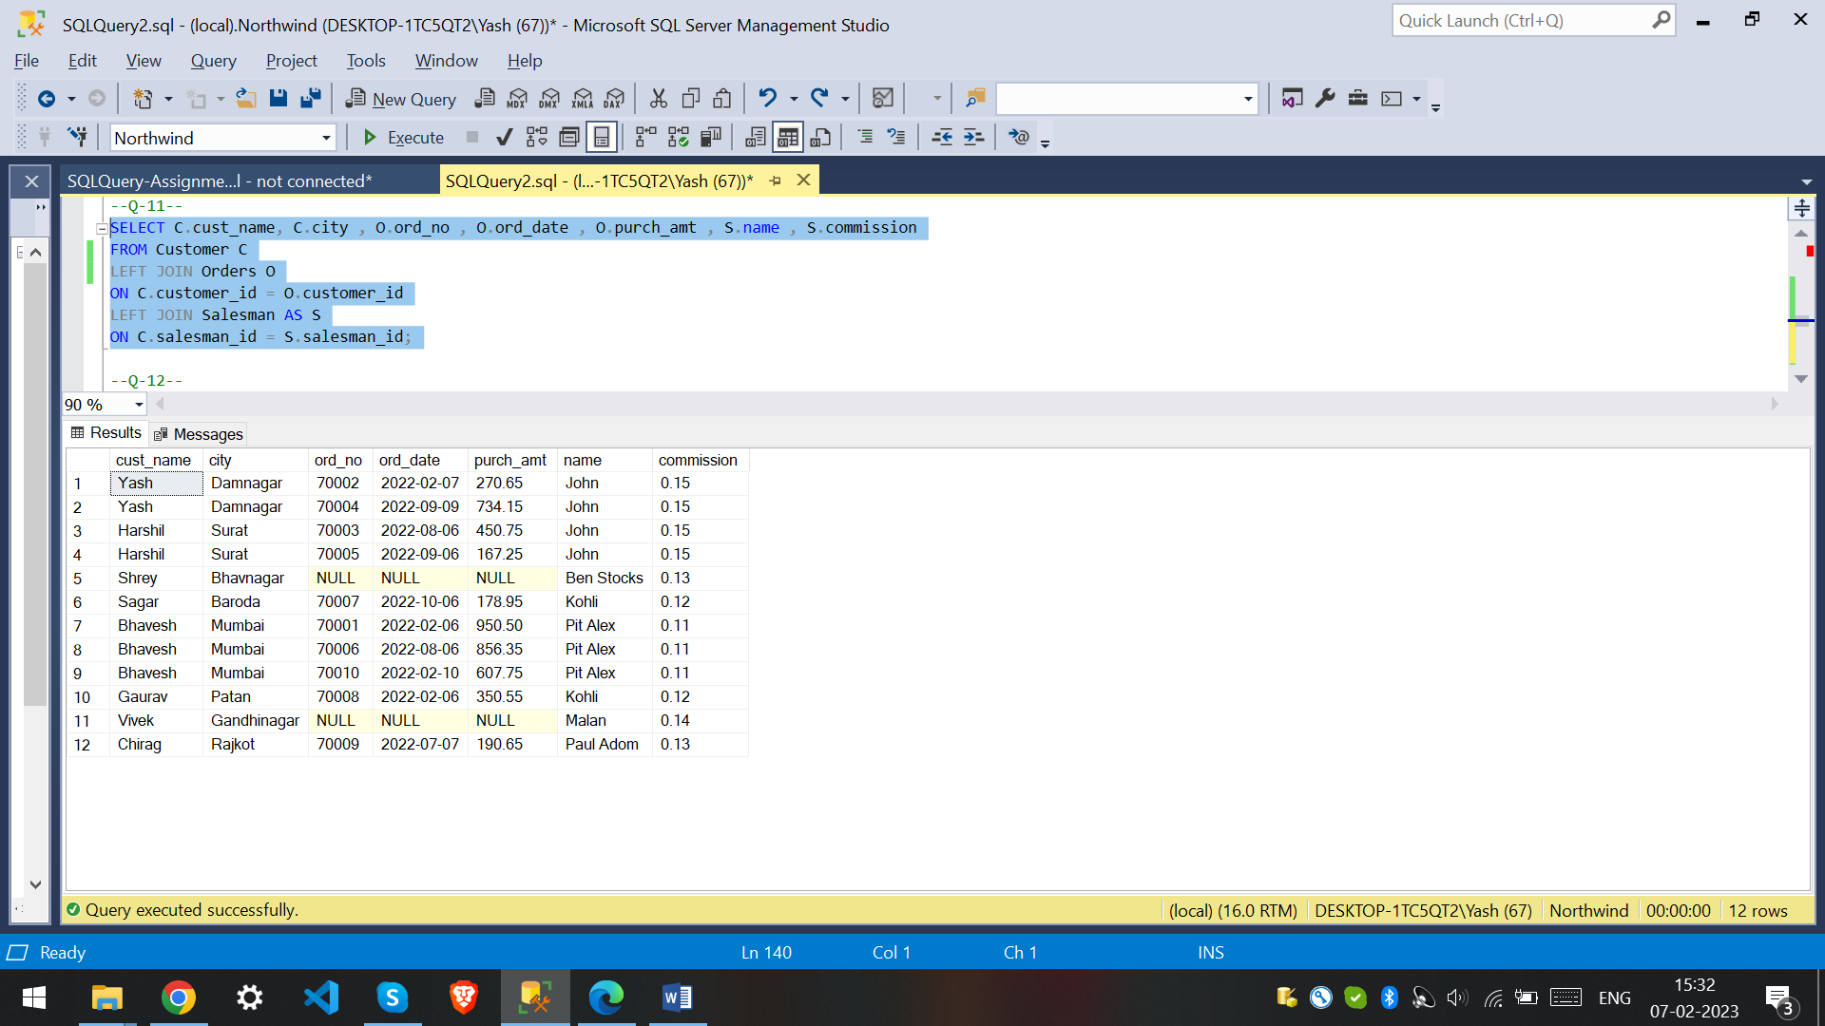

12. Write a SQL statement to generate a list in ascending order of salespersons who work either for one or more customers or have not yet joined any of the customers

SELECT S.name,count(C.customer_id) AS total_customers

FROM Salesman S

LEFT JOIN Customer C

ON C.salesman_id = S.salesman_id

group by S.name

order by count(C.customer_id);

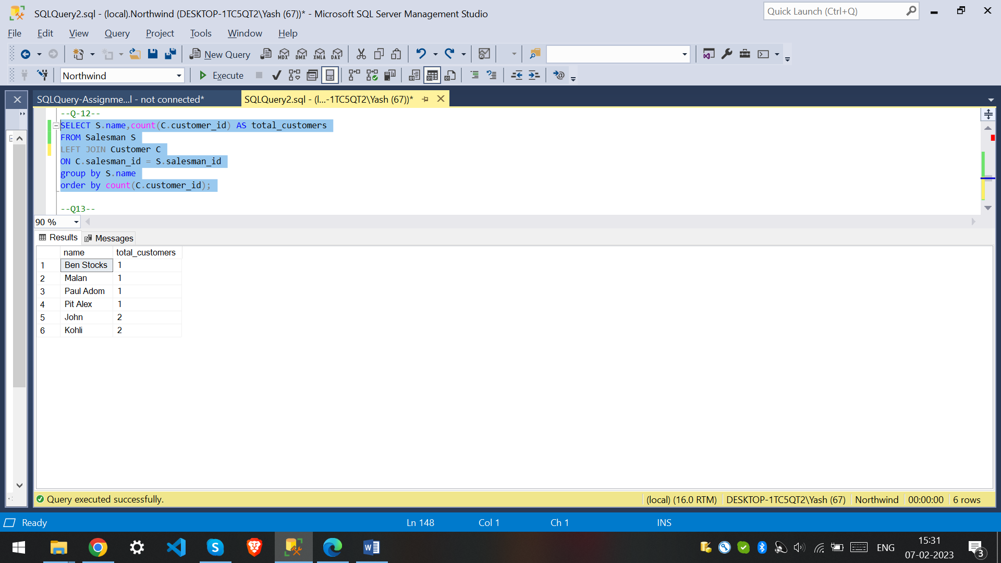

13. write a SQL query to list all salespersons along with customer name, city, grade, order number, date, and amount.

SELECT S.name , C.cust_name , C.city , C.grade , O.ord_no , O.ord_date , O.purch_amt

FROM Salesman S

LEFT JOIN Customer C

ON S.salesman_id = C.salesman_id

LEFT JOIN Orders O

ON S.salesman_id= O.salesman_id;

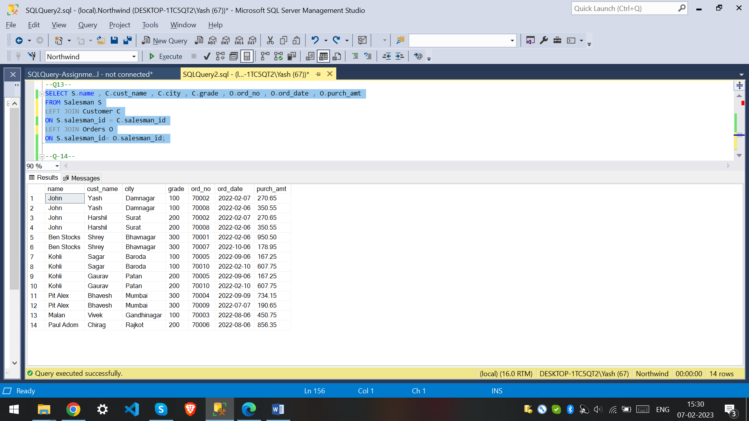

14. Write a SQL statement to make a list for the salesmen who either work for one or more customers or yet to join any of the customers. The customer may have placed, either one or more orders on or above order amount 2000 and must have a grade, or he may not have placed any order to the associated supplier.

SELECT S.salesman_id,S.name

FROM Salesman S

LEFT JOIN Customer C

ON S.salesman_id = C.salesman_id

LEFT JOIN Orders O

ON C.customer_id = O.customer_id

WHERE (O.purch_amt > 2000 AND C.grade IS NOT NULL) OR C.customer_id IS NULL;

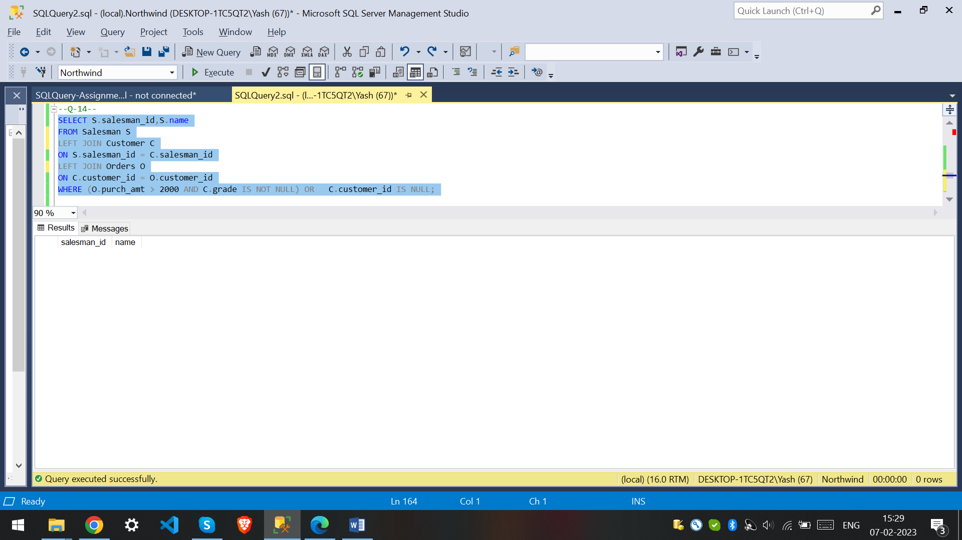

15. Write a SQL statement to generate a list of all the salesmen who either work for one or more customers or have yet to join any of them. The customer may have placed one or more orders at or above order amount 2000, and must have a grade, or he may not have placed any orders to the associated supplier.

SELECT S.salesman_id,S.name

FROM Salesman S

LEFT JOIN Customer C

ON S.salesman_id = C.salesman_id

LEFT JOIN Orders O

ON C.customer_id = O.customer_id

WHERE (O.purch_amt > 2000 AND C.grade IS NOT NULL) OR C.customer_id IS NULL;

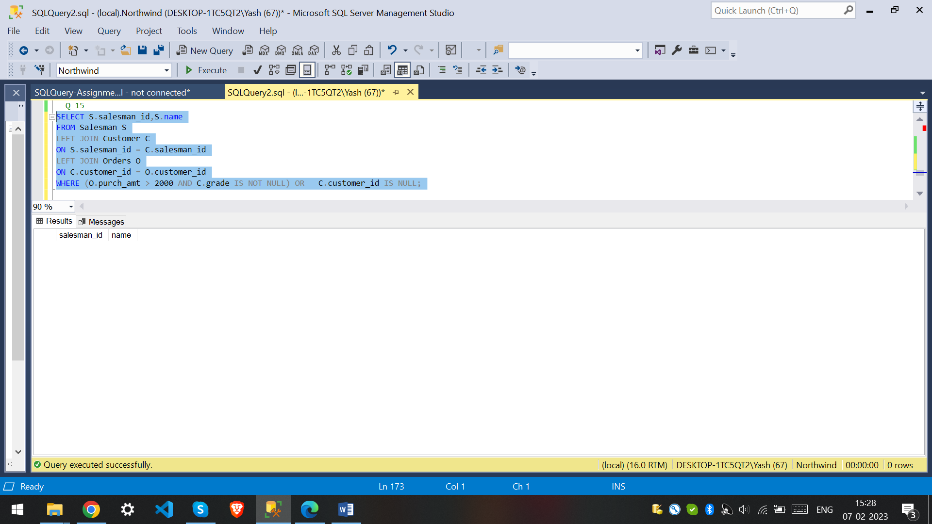

16. Write a SQL statement to generate a report with the customer name, city, order no. order date, purchase amount for only those customers on the list who must have a grade and placed one or more orders or which order(s) have been placed by the customer who neither is on the list nor has a grade.

SELECT C.cust_name , C.city,O.ord_no,O.ord_date,O.purch_amt

FROM Customer C

FULL OUTER JOIN Orders O

ON C.customer_id = O.customer_id

WHERE (C.grade IS NOT NULL) ;

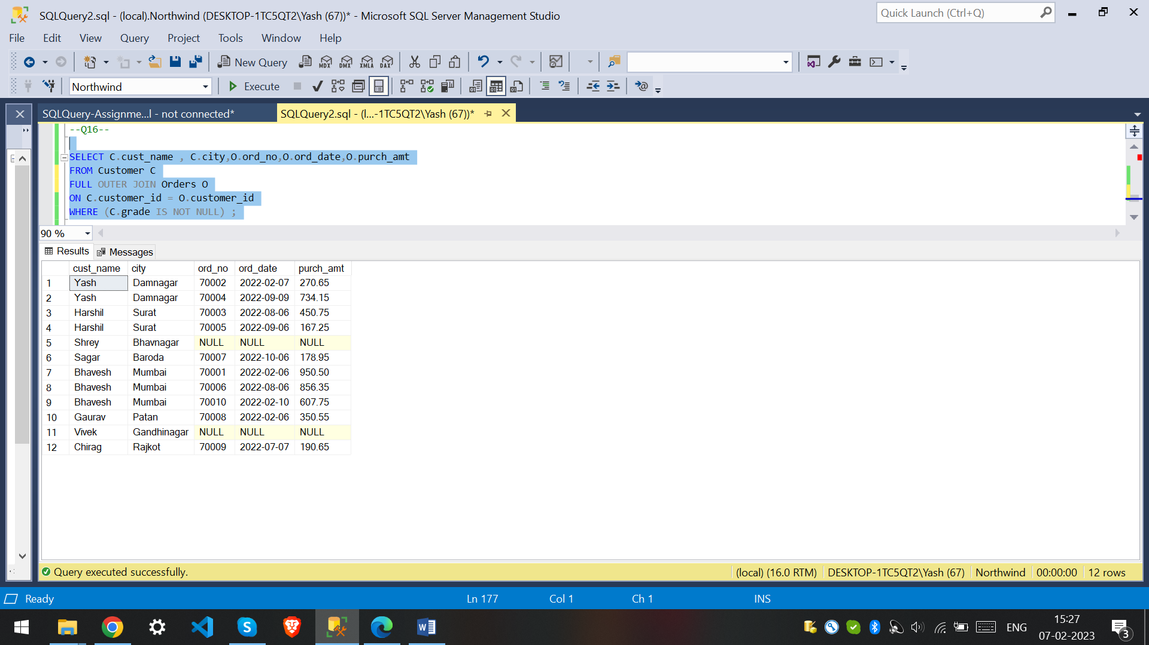

17. Write a SQL query to combine each row of the salesman table with each row of the customer table

SELECT * FROM Salesman CROSS JOIN Customer;

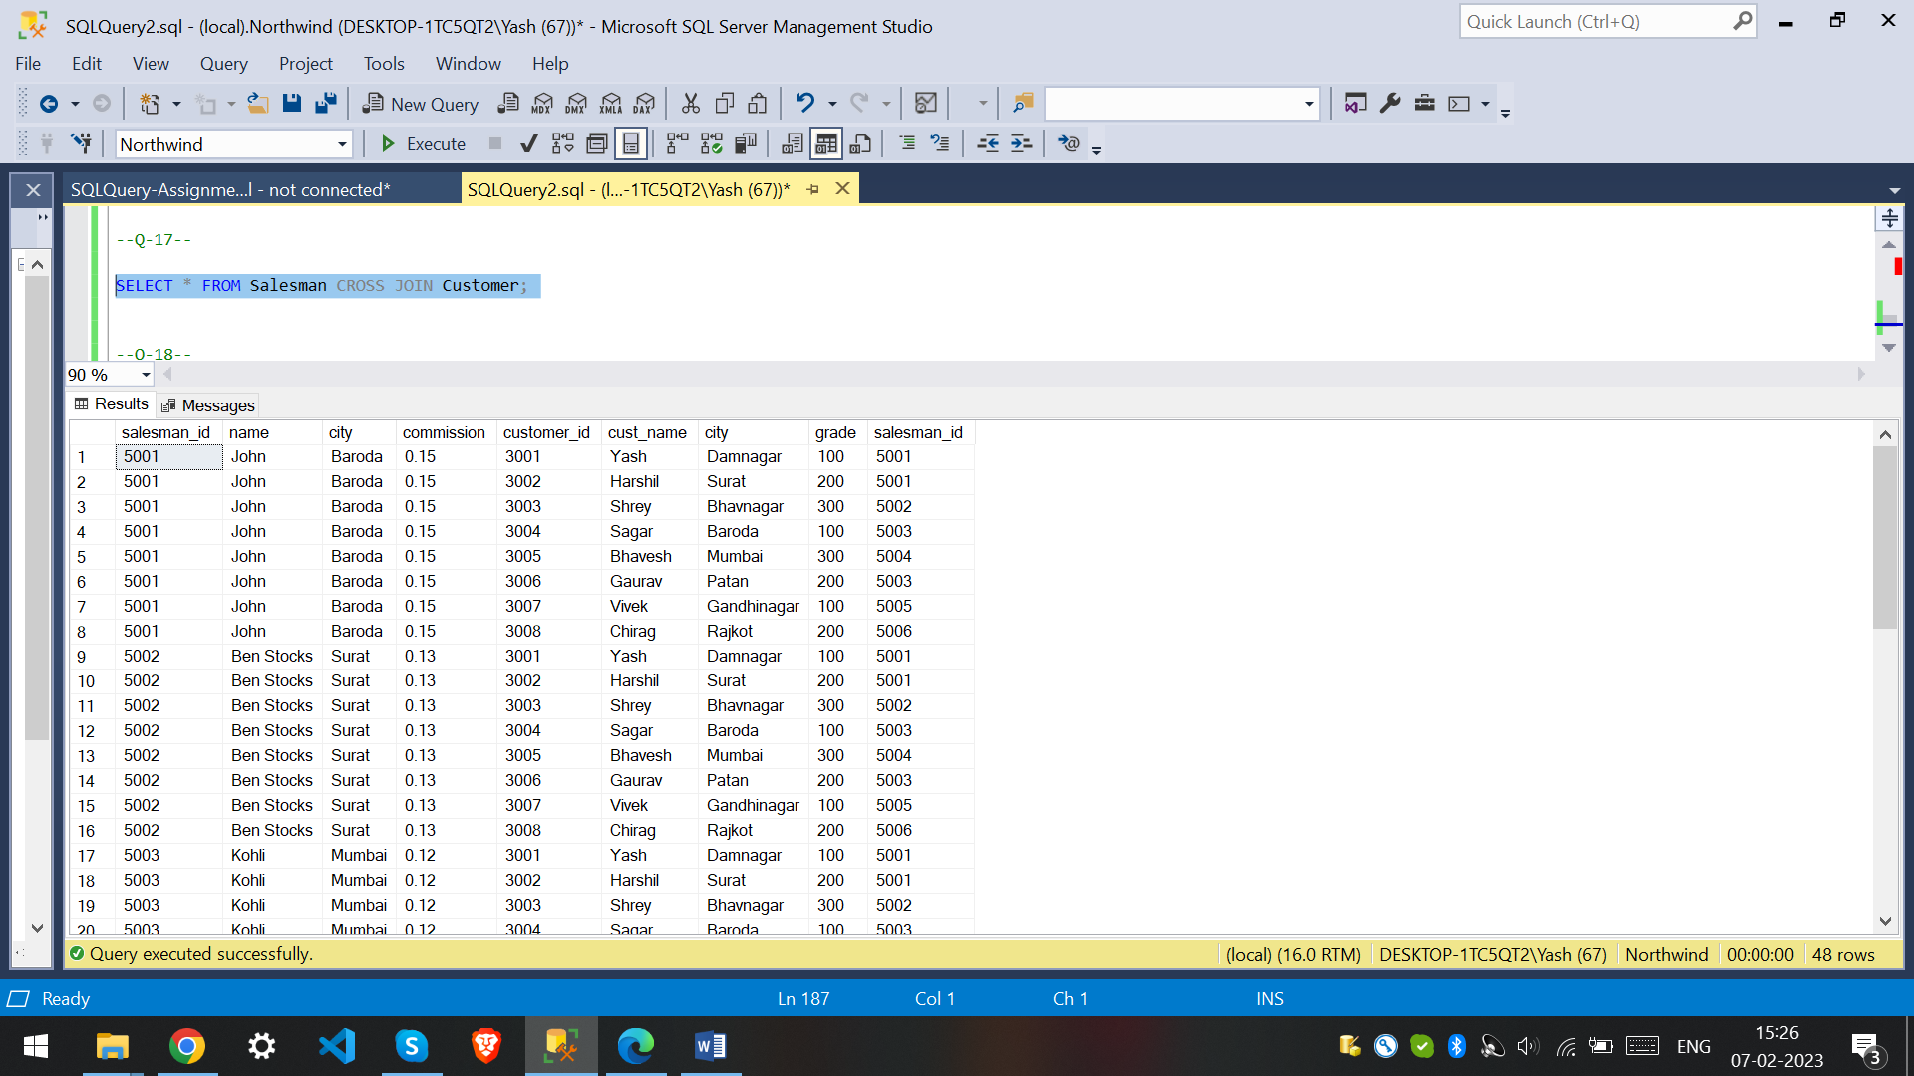

18. Write a SQL statement to create a Cartesian product between salesperson and customer, i.e. each salesperson will appear for all customers and vice versa for that salesperson who belongs to that city

SELECT * FROM Salesman S

CROSS JOIN Customer C

WHERE S.city = C.city;

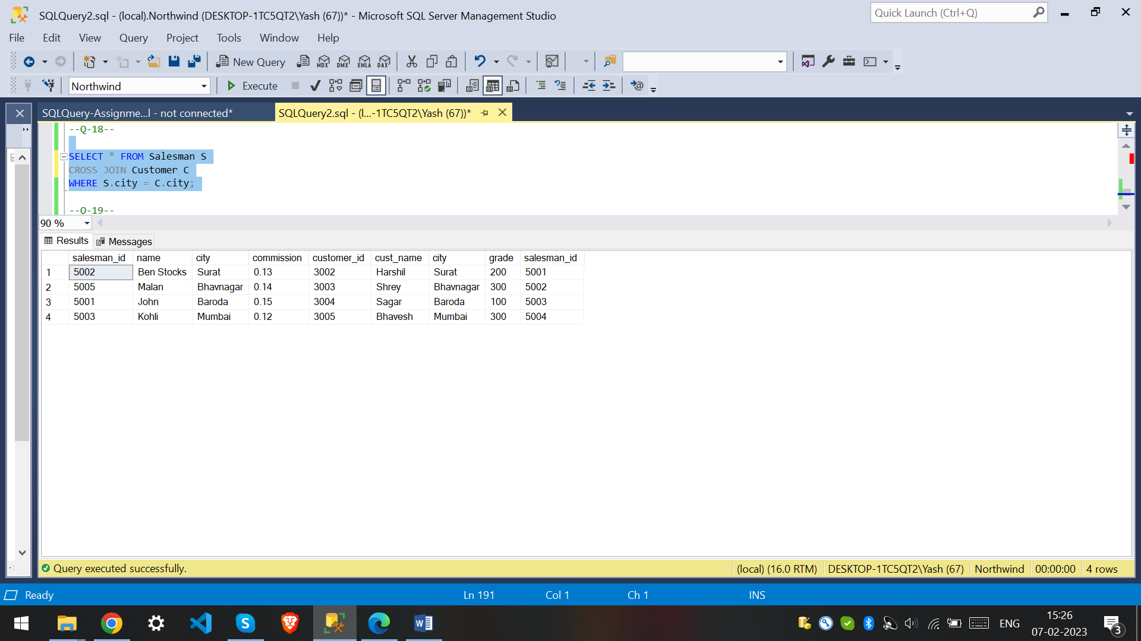

19. Write a SQL statement to create a Cartesian product between salesperson and customer, i.e. each salesperson will appear for every customer and vice versa for those salesmen who belong to a city and customers who require a grade

SELECT *

FROM Salesman S

CROSS JOIN Customer C

WHERE S.city IS NOT NULL

AND C.grade IS NOT NULL;

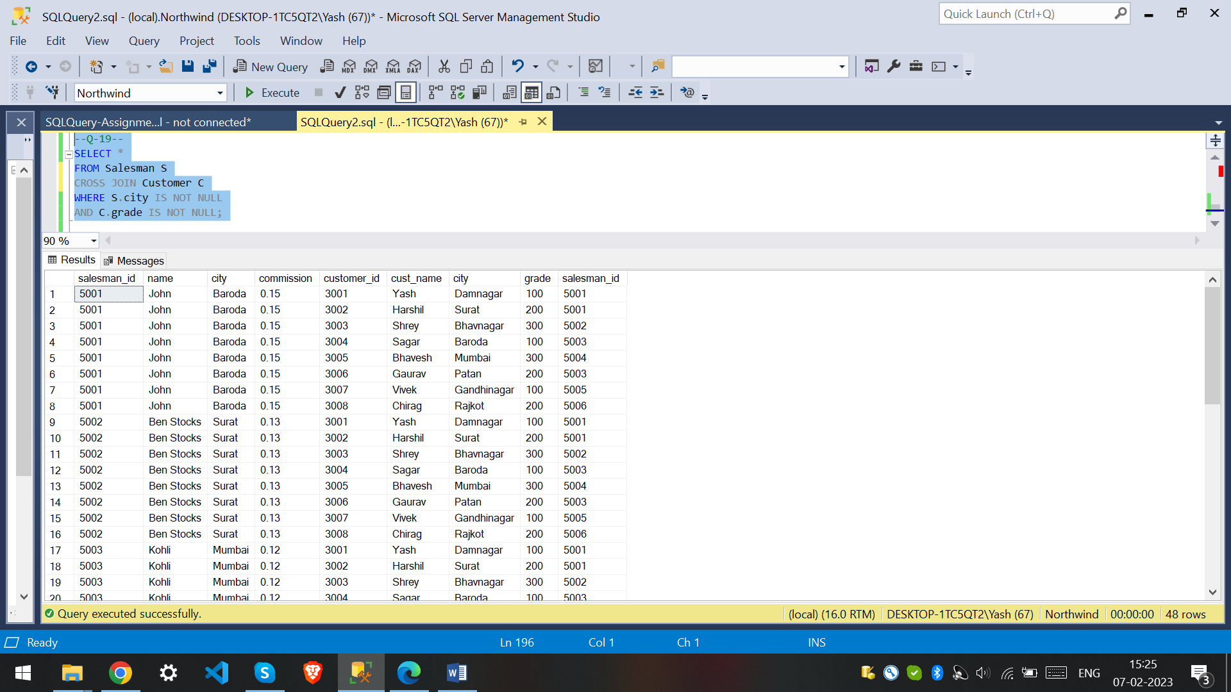

20. Write a SQL statement to make a Cartesian product between salesman and customer i.e. each salesman will appear for all customers and vice versa for those salesmen who must belong to a city which is not the same as his customer and the customers should have their own grade

SELECT *

FROM Salesman S

CROSS JOIN Customer C

WHERE S.city IS NOT NULL

AND S.city <> C.city AND C.grade IS NOT NULL;

